***Repertoire is Everything***

Mary Land

mary.land@wmich.edu

Habits Institute

June 2024

Without a doubt, one of the band teacher’s most important responsibilities is the selection of music for their ensemble. When teachers consider their curriculum requirements, programming needs, technical limitations of the ensemble, and musical possibilities, selecting music for band can be a baffling task. Some items to consider, does the music have:

1. A well-conceived formal structure
2. Creative melodies and countermelodies
3. Harmonic imagination
4. Rhythmic vitality
5. Contrast in all musical elements
6. Scoring which represents the best options for beautiful tone and timbre
7. An emotional, moving outcome
8. Do you like it enough to devote the required time to prepare it

**Where To Begin?**

* What musical experiences do I want my students to have while in the program?
* Which composers do I want my students to perform and learn about?
* Is my repertoire selection balanced between standards (core war horses) and contemporary works?
* Include as LEAST one under-represented composer on EVERY concert.

**Concert Programming**

Concerts are a venue to share musical experiences with an audience. A concert which is fun to perform and enjoyable to listen to has musical interest and variety, and centers on the developing talents of the ensemble. The following is a concert programing format I follow:

***Opener:***

Establish a positive atmosphere and an aura of confidence with an energetic piece…but not too difficult. This allows your students to settle down, relax and perform their best.

***Major WorK:***

This is your big piece with the highest musical quality.

***Lyrical Piece:***

Provides a contrast to the first two pieces. This selection demonstrates beautiful, even predictable, phrases which demonstrate sensitive playing.

***Novelty Tune:***

Feature an outstanding section or a guest soloist.

***Closer:***

This is a perfect place for a march which will have your audience members whistling the tunes as they leave feeling positive about the band program.

**Composers**

Students need to see themselves. Composers should reflect your students and your audience. Your students need models. Program music from under-represented groups. Make every effort to diversify your composers on every concert.

**Resources:**

* Institute for Composer Diversity – [www.composerdiversity.com](http://www.composerdiversity.com)
* …And We Were Heard -www.andwewereheard.org
* Jodie Blackshaw – [www.jodieblackshaw.com/female-band-composers](http://www.jodieblackshaw.com/female-band-composers)
* The Wind Repertory Project – windrep.org
* Bandquest – bandquest.com
* Teaching Music Through Performance – all volumes
* State Lists
* Professional Journals
* Attend *Professional Learning Clinics* and find the new music reading clinics
* Instrumental Music Education Text Books
* Network: Ask your mentors ☺

**Ruth Peterson:**

As I taught middle school band for more than 28 years, I had my favorite composers and still do - Brian Balmages, William Owens, Robert W. Smith, Mekel Rogers, Ed Kiefer, Eric Osterling, Victor Lopez, James Swearingen, and the list goes on. I have added Adrian B. Sims, JaRod Hall, Katajh Copley, Kevin Day, Omar Thomas, Randall Standridge, John Mackey, and more. I am leaving off the obvious wind band composers who are so historically important. The only woman composer I knew of was Anne McGinty for much of my career. I now can add Christina Huss, Laura Fleet Estes, Danielle Fisher, Michele Fernández, Julie Giroux, Jodie Blackshaw, Heather Hoefle, Haley Woodrow, Alex Shapiro, Carol Brittin Chambers, and Erin Keeton-Howard to my list just to name a few.

I believe we should all be selecting high-quality repertoire for our students; however, neither you nor I can meet the needs of band students who are female or BIPOC without becoming aware of women wind band composers and BIPOC wind band composers. There is also a need to know those with compositions accessible to middle school and high school students.

Because women make up half the population but definitely not half of all wind band composers, I started making a list of the women wind band composers and their works in a very simple spreadsheet for band directors to peruse despite their limited time.

We have a real need to nurture young women with a desire to compose, especially Black women. I hope band directors will use the list as intended..."Do the best you can until you know better. Then when you know better, do better." (Maya Angelou)

[https://docs.google.com/.../1XKM4IF23Z.../edit...](https://l.facebook.com/l.php?u=https%3A%2F%2Fdocs.google.com%2Fspreadsheets%2Fd%2F1XKM4IF23Z_sVyqrF6GIZ6kDW6CR3WOWCcCDr88LAdCE%2Fedit%3Fusp%3Dsharing%26fbclid%3DIwZXh0bgNhZW0CMTAAAR2XUTarNKEqtMfrxeGq7iqOydFw57hfL6gd_sGgYOBIS3rL0wFbBbJPsy8_aem_fqmHE2FBF4TPARmxmU2hwQ&h=AT0imOcODl8s5-kKzyTgr89wDKnySOHe501kIUM1ybvNeKurDbkf1xOyrVcaOBSMNCeQu8V-rP0ARlh57yrSMp372VNdbwTM7fZJgy3clvaOR0o_myPHk1CfgvCoZ0zo_nGrMX8Iqg&__tn__=-UK-R&c%5b0%5d=AT0CWZ1nz7N0ssTsVMHYz3kzecWY3yRrJ3UnmdHvVDIRV0LlUmkZLjW6pigbDb-5qq1b49E7vorqVvM24mxnsuiNcXYFd2X3LRQnjQUAKv1bqb3MOwlVa8RblW7p14atmH8FDffcw9DK3Fy_xRO9EGTRvJM)

[[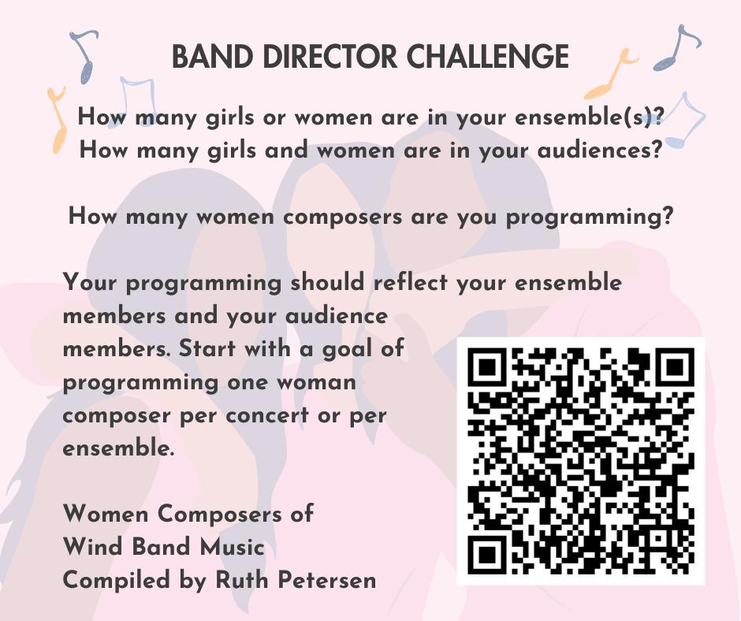](https://www.facebook.com/photo/?fbid=10161415148938895&set=a.138878318894&__cft__%5b0%5d=AZU_kKti45ksA9H_0XK5_e-ffZYEnwzDwwbK39b0gZrGLaCgO99GheBYyB1_Owf3F9bqbJhskAq05ltJ8L5YW6JY5MKJlQBRpxlSuI4NqpbU8px5AgUwv1k7AuxG8HE4L6Y&__tn__=EH-R)](https://www.facebook.com/photo/?fbid=10161415148938895&set=a.138878318894&__cft__%5b0%5d=AZU_kKti45ksA9H_0XK5_e-ffZYEnwzDwwbK39b0gZrGLaCgO99GheBYyB1_Owf3F9bqbJhskAq05ltJ8L5YW6JY5MKJlQBRpxlSuI4NqpbU8px5AgUwv1k7AuxG8HE4L6Y&__tn__=EH-R)

**Programming Post Covid-19:**

Look for the *Flex Band* arrangements. We may be facing small groups with unusual instrumentation which come to us on a rotating schedule. The *Flex Band* arrangements work well for this type of teaching. Frank Tichelli is re-arranging many of his pieces into this *Flex Band* style.

*Connecting with students, and maintaining a sense of musical community, is****everything****during this time. That’s why the wisest teachers among us are encouraging colleagues to keep it simple. Don’t be overwhelmed by the onslaught of resources. What truly matters is making that personal connection, whether it’s through video-chats, texts or just good old-fashioned phone calls.*